**Eval Guru – Your AI Exam Evaluator**

**1. Abstract:**

Evaluation Guru is a simple and smart AI-based evaluation platform built for students following the JNTUK R23 syllabus. It is especially useful for sincere students who want to test their marks, improve their exam writing skills, and understand their knowledge level before the actual exam.

Eval Guru allows students to attempt random previous year question papers (PYQs), write their answers within a timer (just like a real exam), and then upload their answer sheets. The platform uses AI to evaluate the answers and gives a score out of 70 along with proper feedback, just like a teacher.

It also saves your exam history so you can track your progress over time. With features like random PYQ selection, a real exam timer, AI-generated results, and detailed evaluation reports, Eval Guru helps students practice smartly and improve with every test.

**2. Objectives:**

* To provide an accessible, AI-powered exam evaluation platform aligned with the **JNTUK R23 syllabus**.
* To help sincere students assess their knowledge and practice under real exam conditions.
* To improve exam writing skills, time management, and confidence before final exams.
* To offer instant, detailed AI feedback and marks, reducing the dependence on manual evaluation.
* To maintain a record of past performances, enabling students to track progress over time.
* To encourage consistent practice through features like **random PYQ selection** and an integrated timer.

**3. Problem Statement and Proposed Solution:**

**Students preparing for JNTUK R23 exams face challenges due to:**

* Limited access to evaluated practice papers
* Lack of consistent, timely feedback on performance
* Difficulty managing time effectively during exams
* Uncertainty about knowledge gaps before final assessments

**Proposed Solution – Eval Guru:**

* AI-powered platform for evaluating handwritten exam answers
* Built-in timer to simulate real exam conditions
* Random PYQ selection for varied practice
* Automated, clear scoring and improvement feedback
* Score history tracking to monitor progress over time

**4. Tech Stack:**

i) **Frontend:**  
Responsive web interface developed using **HTML5**, **CSS3**, and **JavaScript**, designed for smooth user experience across desktop and mobile devices.

ii) **Backend:**  
Server-side logic implemented with **Node.js** and **Express**, managing exam data processing, user sessions, and AI evaluation requests securely and efficiently.

iii) **AI Evaluation Engine:**  
Integration with **OpenAI GPT models** to analyze and score handwritten answers, generate feedback reports, and suggest improvements in real time.

iv) **Database & Storage:**  
**LocalStorage** for exam history persistence on user devices; scalable cloud storage (optional) for managing uploaded answer sheets and records securely.

v) **Timer & Exam Simulation Module:**

* Built-in **JavaScript timer** replicating real exam durations and enforcing time limits
* Automatic state saving and restoration to support refresh or accidental tab closure

vi) **File Handling & Validation:**

* Secure file upload interface supporting image and document formats (JPEG, PNG, PDF, DOC, DOCX)
* Client-side validation for file types and size constraints

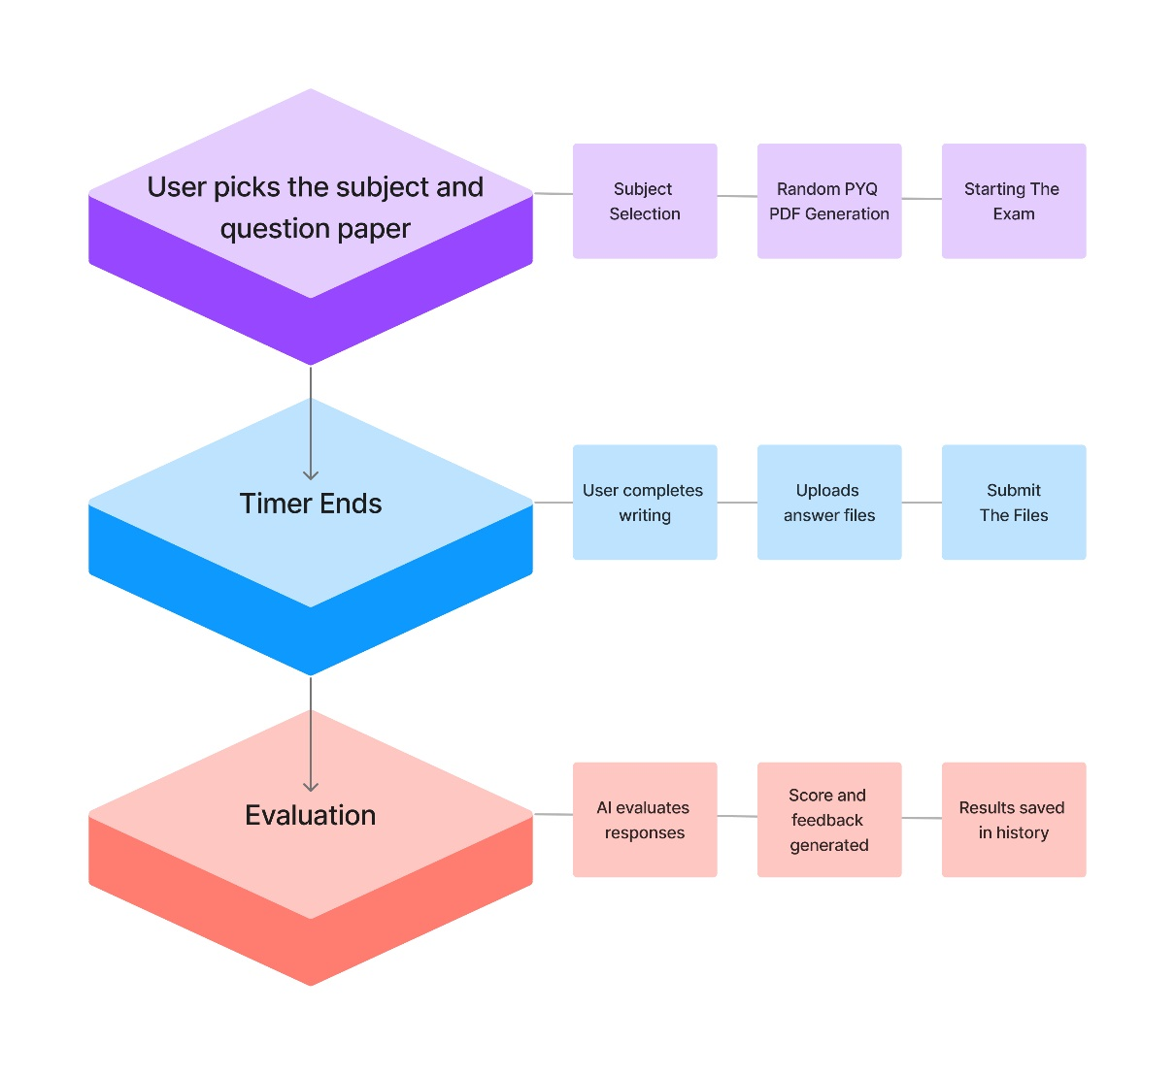

**4. Key Features:**

* **Automatic Evaluation:** AI analyzes answers and generates marks and feedback instantly.
* **Random PYQ Selection:** Easily pick random past papers to simulate real exams.
* **Integrated Timer:** Helps students practice time-bound writing and manage exam stress.
* **Performance History:** Saves all previous attempts, scores, and feedback for progress tracking.
* **Subject Flexibility:** Supports multiple subjects as per JNTUK R23 syllabus.
* **Simple Upload:** Students can upload images or PDFs of their handwritten answers.
* **Clean, Responsive Design:** Works on mobile and desktop devices.

**6. Development Roadmap:**

**Phase 1 (Completed):**

* Core AI evaluation engine development
* PYQ database setup
* Timer and history modules

**Phase 2 (In Progress):**

* Improved evaluation accuracy and feedback detail
* More subjects and papers integration
* Enhanced UI for better user experience

**Phase 3 (Planned):**

* Mobile app version
* User login and personalized dashboards
* Teacher mode for manual grading and annotations
* Performance analytics and study recommendations